A* ALGORITHM
Aim
To write a Python program to implement the A* search algorithm to find the shortest path from a start node to a goal node.
Objective
- To understand the A* search algorithm.
- To find the optimal path between the start node and the goal node.
- To use the cost function f(n) = g(n) + h(n) to select the best node.
- To display the shortest path and its total cost.
Algorithm
- Start.
- Read the graph, start node, and goal node from the user.
- Initialize the open list with the start node.
- Set the cost of the start node as g(n) = 0.
- Calculate the evaluation function using f(n) = g(n) + h(n).
- Select the node with the lowest f(n) value from the open list.
- If the selected node is the goal node, display the path and total cost.
- Otherwise, expand the selected node and find its neighboring nodes.
- Calculate the g(n), h(n), and f(n) values for each neighbor.
- Add the unvisited neighboring nodes to the open list.
- Repeat the process until the goal node is reached.
- If the goal node cannot be reached, display "No Path Found".
- Stop.

Flowchart
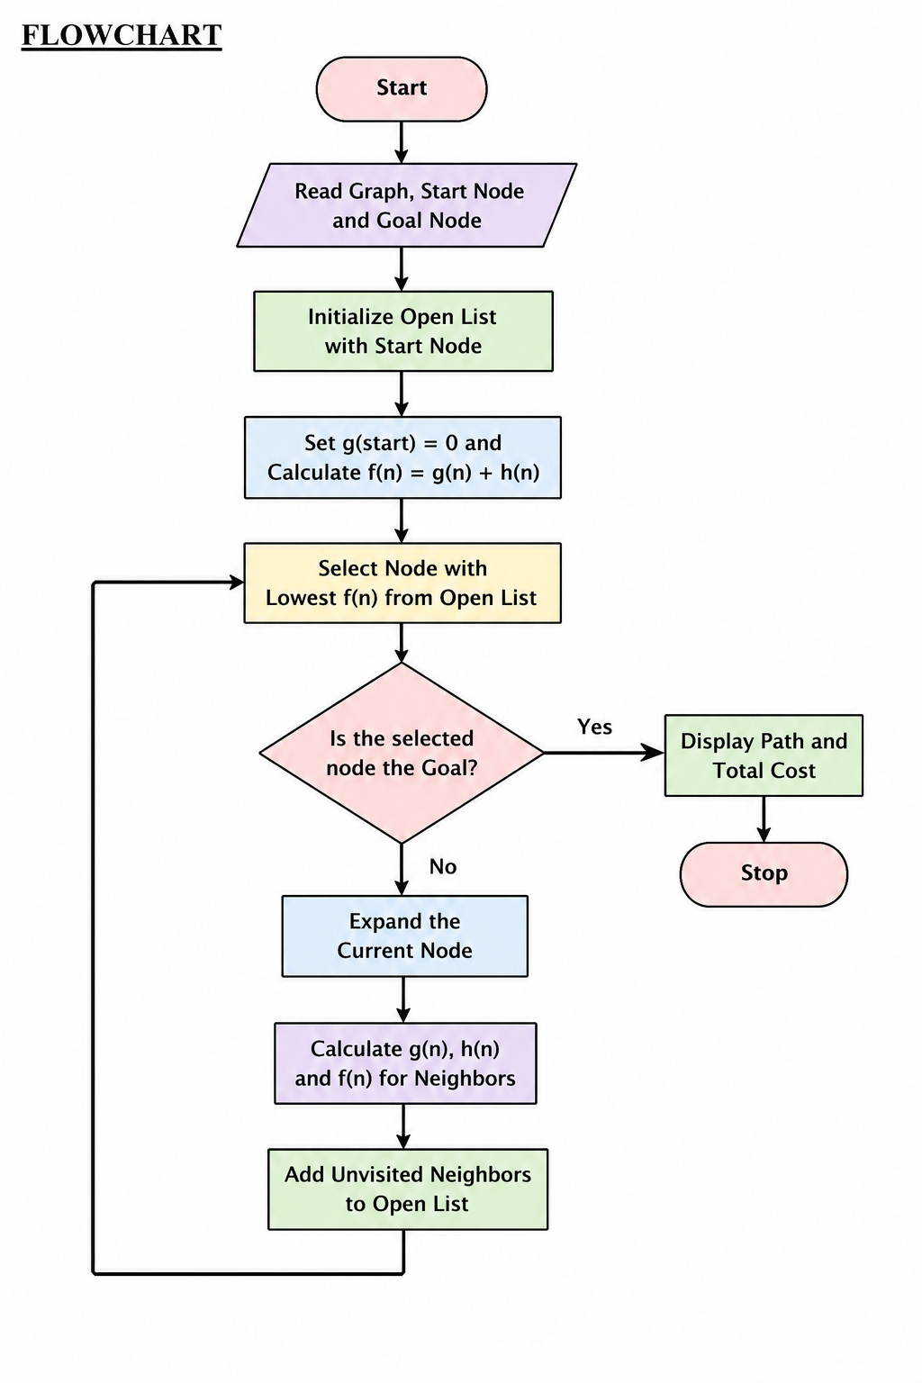
Python Code
import heapq

def a_star(graph, heuristic, start, goal):

open_list = []
heapq.heappush(open_list, (heuristic[start], 0, start, [start]))

visited = set()

while open_list:

f, g, node, path = heapq.heappop(open_list)

if node in visited:
continue

visited.add(node)

if node == goal:
return path, g

for neighbor, cost in graph[node]:

if neighbor not in visited:

new_g = g + cost
new_f = new_g + heuristic[neighbor]

heapq.heappush(
open_list,
(new_f, new_g, neighbor, path + [neighbor])
)

return None, None

graph = {}

n = int(input("Enter the number of nodes: "))

for i in range(n):
node = input("Enter node name: ")
graph[node] = []

e = int(input("Enter the number of edges: "))

for i in range(e):

u = input("Enter source node: ")
v = input("Enter destination node: ")
cost = int(input("Enter cost: "))

graph[u].append((v, cost))
graph[v].append((u, cost))

heuristic = {}

print("\nEnter heuristic values:")

for node in graph:
heuristic[node] = int(
input("Enter heuristic value for " + node + ": ")
)

start = input("\nEnter the start node: ")
goal = input("Enter the goal node: ")

path, cost = a_star(graph, heuristic, start, goal)

if path:
print("\nShortest Path:", " -> ".join(path))
print("Total Cost:", cost)
else:
print("\nNo Path Found")
Output
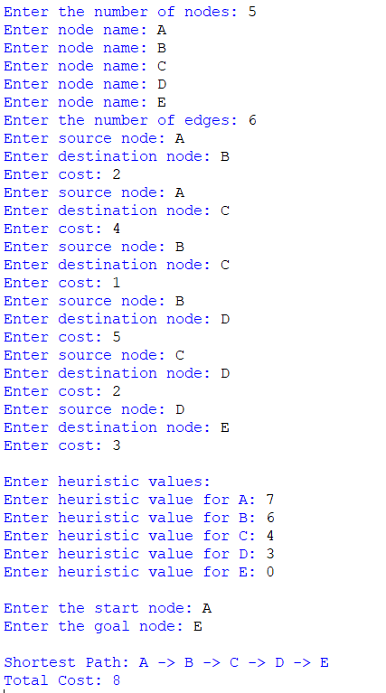
Result
Thus, the Python program to implement the A search algorithm* was executed successfully.
Conclusion
The A* algorithm successfully found the shortest path from the start node to the goal node by using the evaluation function f(n) = g(n) + h(n). The algorithm efficiently combines the actual path cost and heuristic cost to find an optimal solution.

